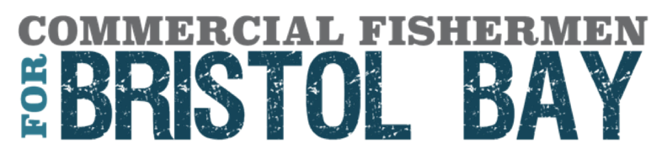
September 6, 2022

Michael S. Regan, Administrator
U.S. Environmental Protection Agency
1200 Pennsylvania Avenue NW
Washington, D.C. 20004
Casey Sixkiller, Regional Administrator
U.S. EPA, Region 10
1200 Sixth Avenue
Mail Code: 14–D12
Seattle, WA 98101

Docket ID No. EPA-R10-OW-2022-0418

Dear Administrator Regan and Regional Administrator Sixkiller:

As members of Bristol Bay’s sustainable fishing industry, we thank the U.S. Environmental Protection Agency (EPA) for issuing the Revised Proposed Determination (RPD) for the Pebble Deposit Area under Section 404(c) of the Clean Water Act. We write to provide comment to this proposal and request the agency move to finalize protections which would prohibit the Pebble Mine and any future mining of the Pebble deposit. We urge the EPA to promptly complete the CWA § 404(c) process and recommend that EPA include several improvements and clarifications in its Final Determination that would permanently protect Bristol Bay’s headwaters from porphyry mining like that proposed for the Pebble deposit. We support the EPA in completing the CWA § 404(c) process as swiftly as possible and call on the agency to finalize comprehensive protections by the end of 2022.
Commercial Fishermen for Bristol Bay (CFBB) is a national coalition of fishermen dedicated to protecting Bristol Bay, Alaska and the 15,000 jobs, $2.2 billion in economic activity, and generational way of life that Bristol Bay’s wild salmon provide. We represent tens of thousands of commercial fishermen and industry members across America who support the EPA’s use of CWA § 404(c) to protect Bristol Bay from harmful mineral development, including the proposed Pebble Mine. We specifically call for CWA § 404(c) action that provides comprehensive protections which prevent Pebble, and other potential large-scale mining operations like it, from storing or disposing of mining waste at the headwaters of the Bristol Bay fishery, including the sub watersheds of the North Fork Koktuli, South Fork Koktuli and Upper Talarik Creek, all of which support the productivity of Bristol Bay’s wild salmon and are under threat from developing the Pebble deposit.

Bristol Bay’s commercial salmon fishery is unlike any other in both its volume of fish, number of jobs, and history of sustainable harvest. Bristol Bay produces the majority of the world’s wild sockeye salmon, with record-breaking harvests the past two years and over 78 million sockeye returning this season alone. Key to Bristol Bay’s consistently strong salmon runs is its pristine and diverse portfolio of fully intact salmon habitat; this intact habitat is especially critical for Bristol Bay’s sockeye salmon as the world’s changing climate impacts ocean conditions and marine productivity.
Without finalized Clean Water Act § 404(c) protections in place, our country stands to lose over 15,000 sustainable jobs, $2.2 billion in annual economic activity, and the largest domestic source of sustainable wild salmon. Most importantly at risk is the irreplaceable, generational way of life of Bristol Bay’s indigenous communities. As such, CFBB recommends that EPA respond to the comments of Bristol Bay’s Tribes and commercial fishing representatives to adopt the below described changes to the RPD and incorporate them into a Recommended Determination for Bristol Bay.

Prohibitions

CFBB is pleased to see the inclusion of a prohibition of dredge and fill materials in the RPD. The use of a section 404(c) prohibition is supported by sound science and the lengthy record developed by the EPA’s 2014 Bristol Bay Watershed Assessment and the Army Corps of Engineers’ (Army Corps) 2020 Environmental Impact Statement (EIS). However, our industry understands that the proposed prohibition as written would only prohibit dredge and fill material associated with the routine construction and operation of the Pebble Mine as described in the Pebble Limited Partnership’s (PLP) 2020 mine plan submitted to the Army Corps. This qualification on the prohibition severely limits its practical effect because it merely prohibits a mine plan already deemed un-permittable by the Army Corps in its 2020 Record of Decision. As written, the RPD’s prohibition is vulnerable to future permit applications that are not identical to the 2020 mine plan but are in effect the same. CFBB does not believe this is what the EPA intended when it determined to utilize a CWA § 404(c) prohibition. To clarify the intent of the prohibition, our industry suggests that EPA adopt language that clearly delineates the defined area in which the prohibition applies, as well as what types of dredge and fill that are specifically being prohibited.

In specifying waters than cannot be used as a disposal area, CFBB suggests that EPA not limit the area to the 2020 Mine Plan footprint. Instead, the EPA should prohibit discharges into designated rectangular survey system township, range, and section units that encompass: (1) areas PLP proposed to use in the 2020 Mine Plan as well as (2) areas PLP proposed as other options for mine site tailings storage facilities and the water treatment ponds as analyzed and rejected in the Army Corps’ EIS process. Next, CFBB suggests that EPA provide greater specificity as to the type of mining-related activities at the Pebble deposit which are being prohibited. Language to this effect may be:

1. prohibit . . . the discharge of dredged or fill material for the construction and routine operation of a large-scale porphyry mine at the Pebble deposit; or

2. prohibit . . . the discharge of dredged or fill material for the construction and routine operation of the 2020 Mine Plan and substantially similar mine plans.

Prohibition language such as this will ensure that the CWA § 404(c) prohibition addresses the real issue at stake: that dredge and fill material associated with mining the Pebble deposit poses an unacceptable adverse impact to the fisheries resources of the Bristol Bay Region.

Restrictions

CFBB appreciates that EPA is seeking to remove the threat of future mine plans to develop the Pebble deposit through use of a restriction on any future mine proposals that would result in adverse effects “similar or greater in nature and magnitude” to the 2020 Mine Plan. However, the restriction as drafted, with emphasis on numerical standards for triggering the restriction and use of “similar or greater,” is vulnerable to future proposals from PLP that would be unacceptable based on sound science and the administrative record. This threat is very real as the company behind the proposed Pebble Mine has previously developed alternative mine plans to work around prior CWA § 404(c) actions proposed by the EPA.

As such, CFBB suggests two modifications that will work in tandem to address this problem. First, EPA should provide more detail as to what constitutes adverse effects “similar or greater in nature and magnitude” as the 2020 Mine Plan. This definition should focus on particular ecological effects supported by sound science, not just numerical standards developed in response to PLP’s 2020 mine plan. It should ensure that the restrictions will provide protections from a mine similar to that analyzed in the 2014 Proposed Determination and the 2014 Bristol Bay Watershed Assessment. Providing this certainty will ensure that the people of Bristol Bay, federal and state regulators, and industry are all clear on the precise meaning and scope of the restrictions prior to any future permitting process of mining in the area, rather than spending unnecessary financial and human resources in a future environmental review process to determine whether the restrictions will be triggered.

Second, EPA should redefine and specify that the “Pebble deposit” is broader than “an area of at least 1.9 by 2.8 miles” or delineated as a 2.5 mile- by 3.5-mile box and instead base the definition of the Pebble deposit on the best available information and science of ecological effects from mining pyritic ore. This could include utilizing PLP’s definition of the Pebble deposit and orebody from the company’s 2021 Preliminary Economic Assessment report, including the full 11 billion tons of measured, indicated, and inferred ore at the Pebble deposit. EPA could also remove reference to a specific border for the Pebble deposit and instead focus the restriction on the character of the orebody. As acknowledged by EPA, the full extent of the Pebble deposit is an estimate based on PLP’s exploration efforts and should not be used as the basis of the restriction. Because the extent of the deposit may expand over time, the agency could focus on the ore type as it is the ecological effect of mining this ore type that EPA uses to support its restriction.

CFBB again extends our thanks to the EPA for its effort to protect the headwaters of our fishery through the Clean Water Act section 404(c) process. This effort is something the Bristol Bay Region and fishing industry have been working toward for over a decade. The importance of finalizing the CWA § 404(c) process cannot be overstated. The importance of these salmon to the indigenous communities of Bristol Bay who have sustained these salmon runs should be reason enough for EPA to move forward with a Recommended and Final Determination. Without action the cultural resources that Bristol Bay stands to lose are irreplaceable and immeasurable. The losses that can be measured include Bristol Bay’s thriving fishing industry, which generates 15,000 renewable jobs, $2.2 billion in annual economic activity, and an irreplaceable sustainable domestic food source. Our country cannot afford to lose this kind of renewable economic engine and we urge the EPA to finalize CWA § 404(c) protections before the end of 2022.

Sincerely,
Commercial Fishermen for Bristol Bay Advisors:

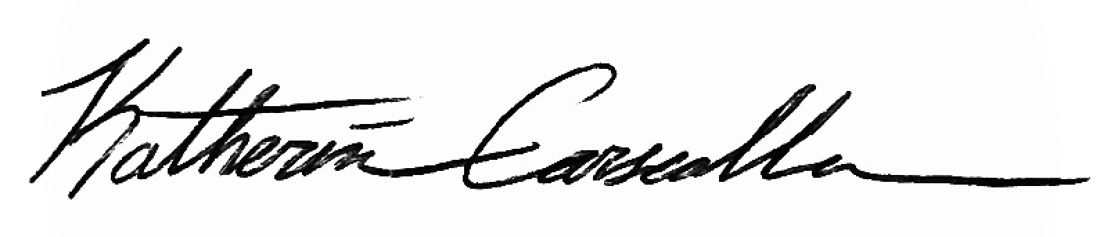  Katherine Carscallen  Executive Director, CFBB  F/V Sea Hawk  PO Box 1252  Dillingham, AK 99576  (907) 843-2006 | 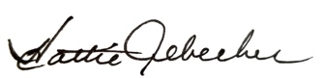  Hattie Albecker  Ugashik Set Netter  101 Olga Lane  Ugashik, AK 99613  (907) 744-6768  aleutgal49@gmail.com | Erica Madison  Madison’s Salmon Co.  3753 West 22th Ave  Anchorage, AK 99517  (907)306-0803  ericamadison@gmail.com
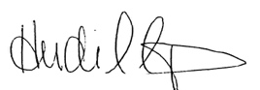  Heidi Dunlap  F/V Toonces  Wild Salmon Company  26 Young St  Asheville, NC 28801  (828)216-2565  thewildsalmonco@gmail.com | 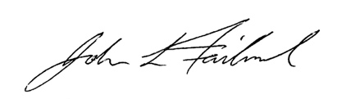  John Fairbanks  F/V SUMO  437 15th St.  Bellingham, WA 98225  (360) 961-3370  john@johnlfairbanks.com | 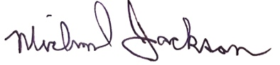  Michael Jackson  F/V Kelley J  615 12th Street  Bellingham, WA 98225  (360)-319-2421  Powderhino@aol.com
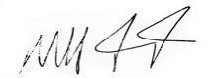  Michael Friccero  Rainy Dawn Services  F/V Miss Gina  Kodiak, AK 99615  (907) 539-1320  mike.clarion@gmail.com | 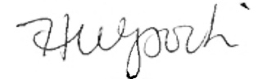  Holly Wysocki  Nushagak Bay Set Netter  100 Aleknagik Lake Road  Dillingham, AK 99576  (907)250-7755  combinequeen@gmail.com | 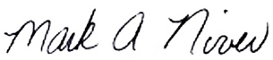  Mark Niver  F/V Salmon Slayer  955 Loch Ness Dr.  Wasilla, AK  (907)232-8167  markniver@yahoo.com

See, Pebble Project Preliminary Economic Assessment NI 43-101 Technical Report, Prepared for Northern Dynasty Minerals Ltd,., Prepared by Ausenco Engineering Canada (effective date: Sept. 9, 2021), Figure 10-2, at p. 109, on file with the Securities and Exchange Commission at: https://www.sec.gov/Archives/edgar/data/1164771/000165495421011600/ndm_ex991.htm.
See, e.g., Northern Dynasty Minerals—Pebble Project Reserves and Resources, https://northerndynastyminerals.com/pebble-project/reserves-resources/.

